***Graphs***

1. Consider the following graph and find the following: (10)
2. The degree of each vertex
3. Make an adjacency list for each vertex

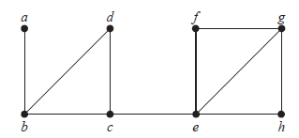

1. Determine whether the following graphs are isomorphic or not. (10)

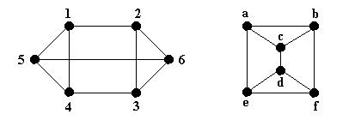

1. Consider the following graph and find the following: (10)
2. Adjacency matrix
3. In-degree and out-degree for each vertex

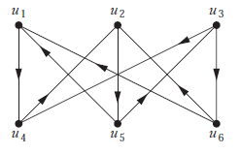

1. Consider the following graph and find, (10)
2. A Eular path or circuit if there is any
3. A Hamilton path or circuit if there is any

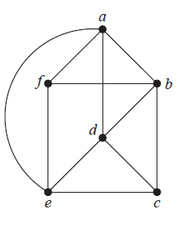

1. A full 5-ary tree has 501 vertices. Find the number of leaves and internal vertices. (10)
2. Draw the spanning tree for this graph by removing the circuits. Draw the spanning tree. (10)

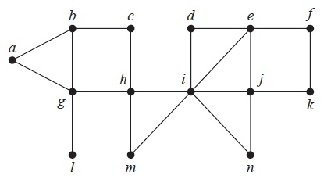

1. Start from vertex **d,** span the following graph using breadth-first search algorithm. (10)

